MINI FLOSSER

Q What is a Miniflosser?

A It is a pre-loaded dental floss holder that makes using dental floss a little easier. The strong, slim and flexible dental floss glides easily between the tight spaces between your teeth.

Q Why do I need to clean between my teeth?

A Plaque and food particles can get trapped between your teeth and under the gum line. These can cause gum disease and tooth decay and are in areas a toothbrush can’t reach. Flossing removes the plaque and food debris in these difficult areas.

Q Why use a Miniflosser?

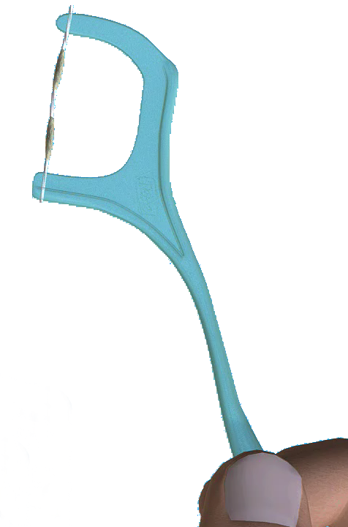
A Some people find it difficult to use normal floss. It is especially difficult for people who can’t grip properly.

Q How do I use it?
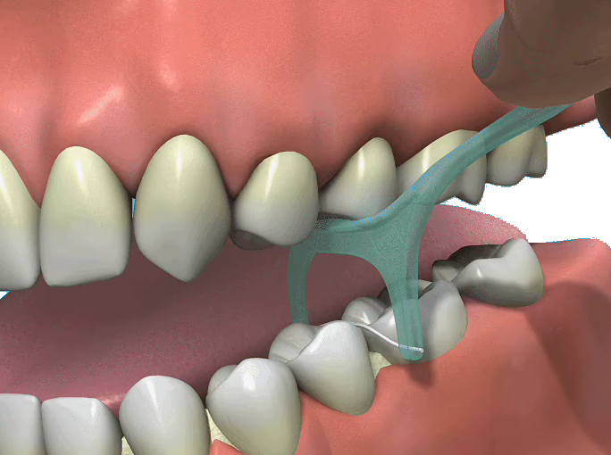
A Insert the Miniflosser in between two teeth and use the specially designed bite plane to gently bite down thus easing the floss into the space between the teeth. Once inserted use a gentle back and forth action to disrupt and remove the plaque. Remove by pulling the floss up away from the gum with a gentle sawing action. Rinse in clean water and repeat in the next space until all the spaces in between the teeth have been cleaned.

